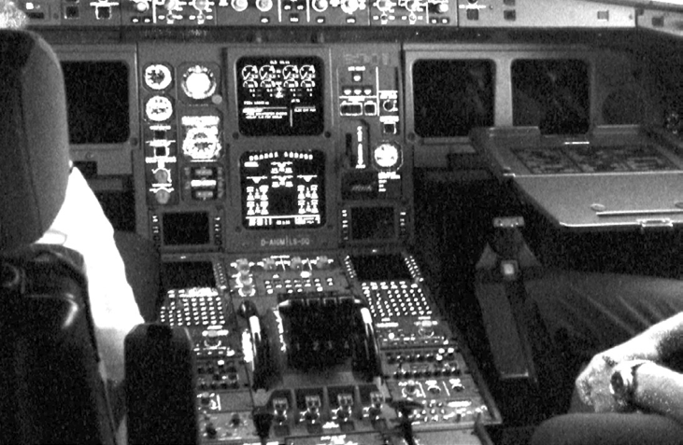

**Page Cache - A**

***Objective: In this lab you will answer questions related to Linux page caching.***

1. Why shouldn’t write operations IMMEDIATELY hit the disk?
2. If a user mode application needs to guarantee consistency across its data on disk (ex. database) what syscall function(s) can the application use to force the update?
3. Pdflush does NOT obey I/O priorities. Is that a good or bad thing? Explain.
4. Pdflush manages the number of threads that are available based on the amount of I/O pending. Is this a serious design error in pdflush? Yes or no, explain.
5. Can Linux kernel page caching guarantee that a power disruption of RAM (ex. blackout) won’t be lose data?